Teacher
Workshops

Sample Schedule  Friday 4:00- 4:30 pm 5:15- 6:00 pm 6:30- 8:00 pm Saturday 7:25- 8:00 am 8:30- 11:45 am 12:15- 1:00 pm 1:30- 4:45 pm 5:15- 6:00 pm 6:30- 9:15 pm Sunday 7:25- 8:00 am 8:30- 11:45 am 12:15- 1:00 pm Arrival Dinner Introductions/Goals Breakfast Workshop Session 1 Lunch Workshop Session 2 Dinner Ropes Course or Indoor Rock Climbing Breakfast Workshop Session 3 Lunch/ Departure  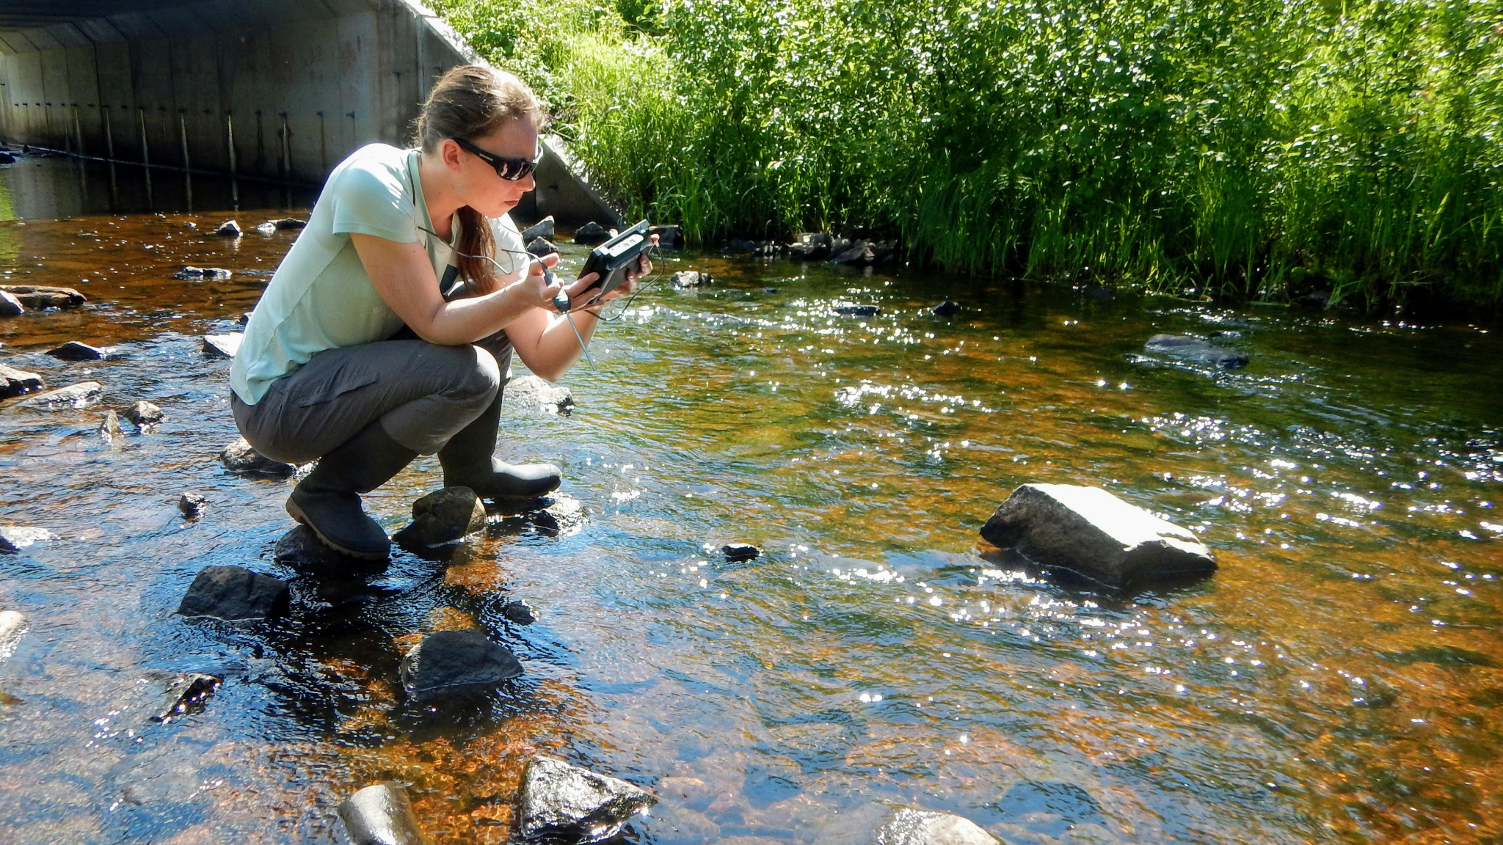  Contact scheduling@wolf-ridge.org for more information | What We Offer  Weekend Workshops at Wolf Ridge for Single Districts/ Schools  Bring a group of teachers up from your district or school to participate in a series of workshops related to outdoor learning. Workshops can be catered to any range of K-12 education from elementary to secondary. See sample workshop topics for more information on programming.  - Stay in The Margaret A. Cargill (MAC) Lodge. The MAC Lodge is divided into different sections and has rooms that have 4-8 beds and private bathrooms and showers in each room. Meals are provided, cafeteria style, in our Dining Hall.  - Workshop times include Saturday and Sunday morning (8:30 -11:45 am), and Saturday afternoon (1:30 -4:45 pm).  - Bring the family! Wolf Ridge would be happy to set up activities for spouses and children, or give suggestions for activities for them to do on their own.  - Saturday evening activities (6:30-9:15 pm) can include either our Adventure Ropes Course or Indoor Rock Climbing, depending on the interest of the group. Campfire space is also available in the evenings.

Weekend Workshops at Wolf Ridge for Individual Teachers
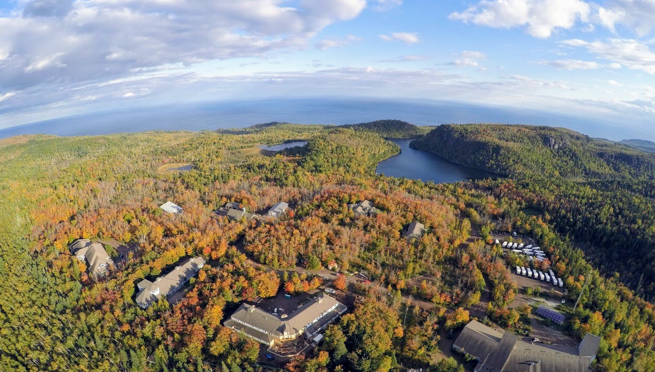
Interested in collaboration with teachers from other districts? Wolf Ridge hosts weekends for individual teachers to sign up to come take part in a weekend of professional development and to network with other teachers across the region that are working towards being a leader of outdoor learning in their school. Contact emily.pavlisich@wolf-ridge.org for more information about when workshop weekends are available.

On-Site Workshops
Stuck on what can be done on the grounds of your building? Wolf Ridge naturalists can come to your school for professional development workshops for groups of teachers. We offer half day or full day workshops with themes and topics connected to your schools goals and needs.

Sample Workshop Topics and Themes
(Don’t see what you’re looking for on this list? Contact emily.pavlisich@wolf-ridge.org to co-create the program that best meets your needs!)
- Basics of outdoor learning- how to get started!
- Naturalist Practices- practices to help our students explore the natural world
- Nature Journaling- from starting out to new ideas
- Outdoor Pedagogy- engage as a student in an outdoor class and reflect on pedagogy techniques
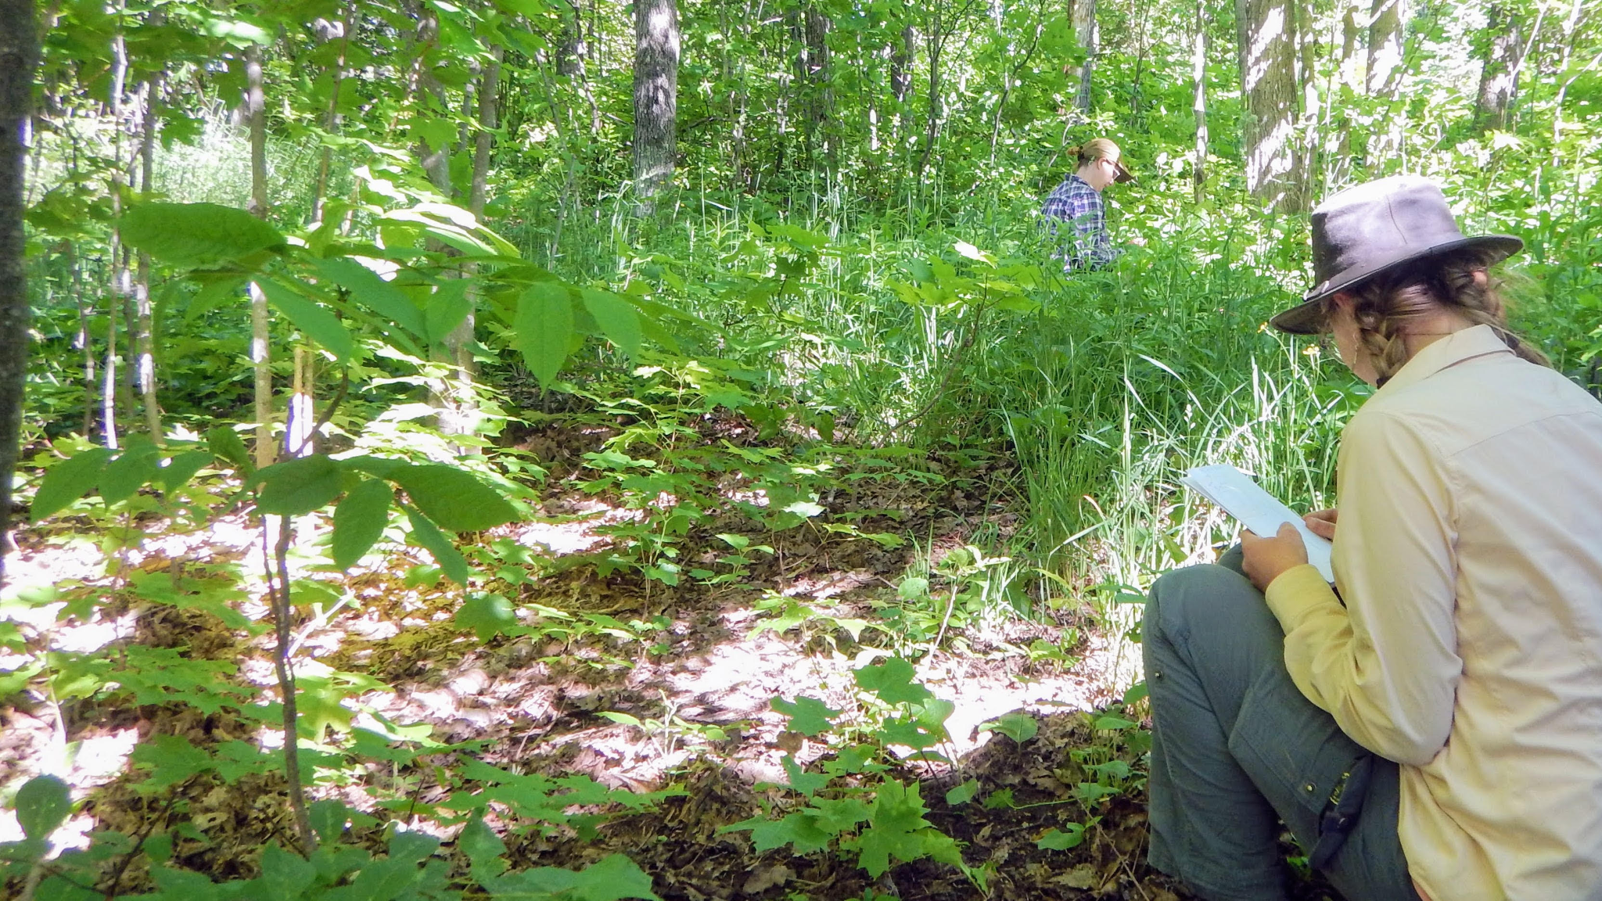
- Phenology- what is it and how to incorporate it all year long
- Outdoor investigations- basics of conducting an investigation and collecting and interpreting data
- Improv and Community Building- learn improv skills and team games
- Citizen Science- learn about ways your students can engage with citizen science projects

Contact scheduling@wolf-ridge.org or emily.pavlisich@wolf-ridge.org for more information

